Assignment 5

Q1. Draw and explain LTE network Architecture .

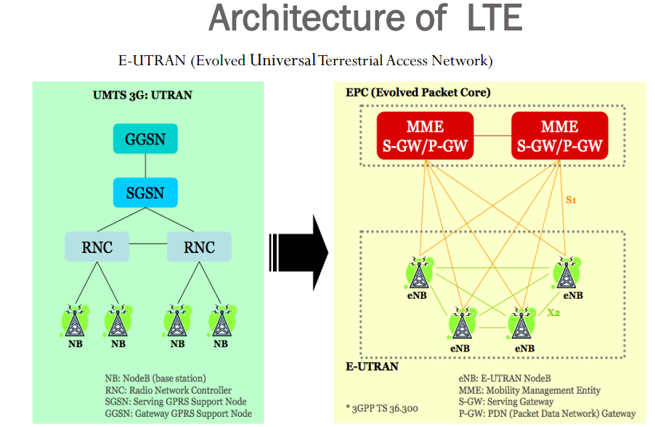
Architecture of LTE
 In the LTE architecture, evolved packet core (EPC) is an IP-based core network
that distributes all types of information over IP, including voice.
 EPC principally includes a Mobility Management Entity (MME), a Serving
Gateway (S-GW) that interfaces with the E-UTRAN, and a PDN Gateway (P-GW)
that interfaces to external packet data networks.
 The entire system is known as the evolved packet system (EPS).
 EUTRAN handles the radio communications between the mobile and the EPC and
has just one component, which is the evolved Node B (eNB).
 eNB in an LTE network replaces Node B in 3G systems and represents a
combination of Node B and the radio network controller (RNC).
Every eNB is connected to the EPC by means of the S1 interface. Precisely, it is
connected to the S-GW by means of the S1-U interface and to the MME by means
of the S1-MME interface.
• The eNB interfaces with User Equipment (UE) and can serve one or several cells at
one time.
• The serving gateway (S-GW) acts as a router that is responsible for routing and
forwarding packets between UEs and the packet data network (PDN), so it
interfaces with the E-UTRAN and a PDN Gateway.
• Moreover, the S-GW serves as a mobility anchor for handover and interworking
with other 3GPP technologies.
The packet data network gateway (PDN-GW) ensures connectivity to the UE to
outer packet data networks, as it represents the EPC’s point of contact with the
external world. A mobile could have simultaneous connectivity with several PDNGWs for accessing multiple packet data networks.
• The PDN-GW is responsible for several functions such as packet filtering, charging
support, policy enforcement, packet screening, IP address allocation for the UE,
QoS enforcement and lawful interception.
• The mobility management entity (MME), manages UE access network and
mobility.
• The MME also controls mobility between LTE and 2G/3G access networks.

Q2. Draw and explain LTE advanced Architecture

LTE- Advanced
 Refers to LTE release 10 and later.
 Deliver a peak data rate of 1000 Mbps in the downlink, and 500 Mbps in the uplink
 Support a maximum bandwidth of 100 MHz
 Supports carrier aggregation, relaying, enhanced MIMO and Coordinated multiple point transmission and reception.
 Carrier Aggregation (CA): LTE-Advanced allows a mobile to transmit and receive on up to five component carriers (CCs), each of which has a maximum bandwidth of 20 MHz.This technique is known as carrier aggregation (CA), thus can fully utilize the maximum bandwidth of 100 MHz.
LTE- Advanced
 Relays: Repeaters and relays are devices that extend the coverage area of a cell. They are useful in sparsely populated areas, in which the performance of a network is limited by coverage rather than capacity. They can also increase the data rate at the edge of a cell, by improving the signal to interference plus noise ratio there.
Improve the coverage, urban or indoor throughput, group mobility, cell edge coverage, and to extend coverage to heavily shadowed areas in the cell or areas beyond the cell range.
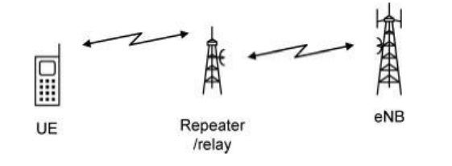
Enhanced MIMO: Multiple transmit and receive antennas and multi-cell MIMO techniques will be applied to offer an enhanced downlink MIMO and enhanced uplink MIMO, improving the downlink and the uplink data rate.
Enhanced MIMO is considered to be one of the major aspects of LTE-Advanced that will allow the system to meet the IMT-Advanced rate requirements.
Coordinated multiple point transmission and reception: Coordinated multipoint transmission (CoMP) is one of the new technologies introduced in LTE-Advanced that is based on orthogonalization techniques to achieve higher spectral efficiency and higher peak rates for normal and edge users. The basic idea is to create multicells in which information is shared between eNB and the data transmission. With this method the transmission and reception can be processed as in a MIMO scenario, hence inter-cell interference (ICI) can be rejected and spatial diversity can be used to increase signal-to-noise ratio (SNR).
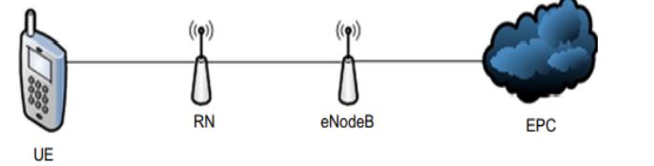
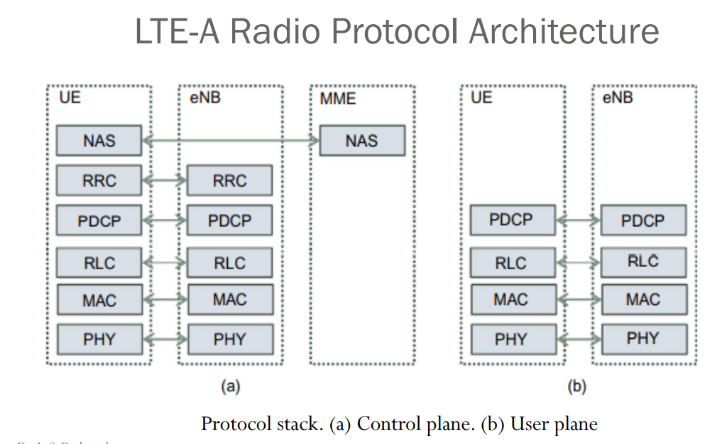
LTE-A Radio Protocol Architecture
The protocol for the user plane includes :
 Packet Data Convergence Protocol (PDCP)
 Radio Link Control (RLC)
 Medium Access Control (MAC)
 PHY protocol
 The control plane stack additionally includes the radio resource control (RRC) and non-access stratum (NAS)
The Physical Layer (PHY): Like LTE, LTE-A uses OFDM technology to cancel the Inter Symbol Interference (ISI).
• The Medium Access Control (MAC): It performs resource scheduling and Hybrid Automatic Repeat Request (HARQ) for retransmission.
• The Radio Link Control (RLC): It manages the delivery of the data. It is responsible for segmentation of data based onTransport Block Size (TBS).
• The Packet Data Convergence Protocol (PDCP) does ciphering, retransmission and header compression of user data.
• The Radio Resource Control (RRC) manages security functions (authentication and authorization), handling mobility, roaming, and handovers.
• The Non-Access Stratum (NAS) is responsible for authentication, registration, connection/session management between UE and the core network.

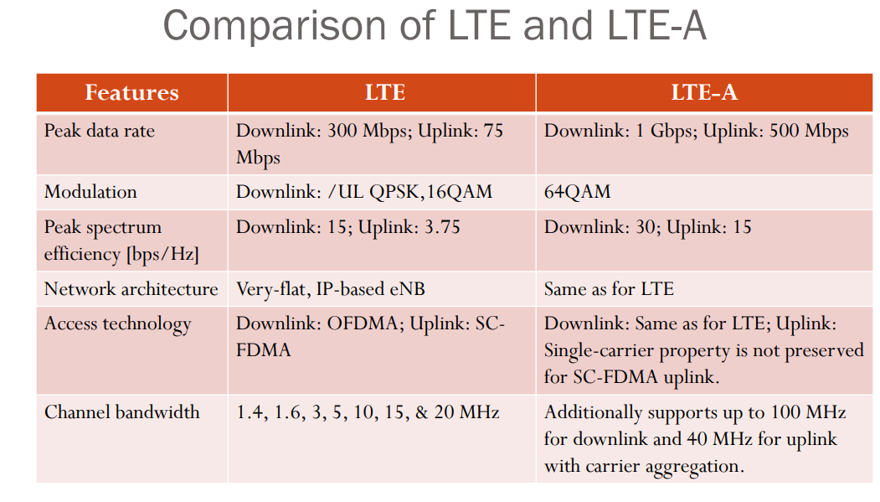
Q3.List out various challenges and requirements for 5G

Capacity (data rate): 1Gbps – ULIMITED?
 High speed and capacity
 Faster data transmission than 4G
 Supports
–Interactive multimedia
–Voice streaming
–Buckle up.. Internet
 More efficient
10-100 times higher user data rate
 10 times longer battery life
 10-100 times more connected devices
 5 times reduced end to end latency
(Latency is the time taken for devices to respond to each other over the wireless network.)
 1000 times higher mobile data volume per area
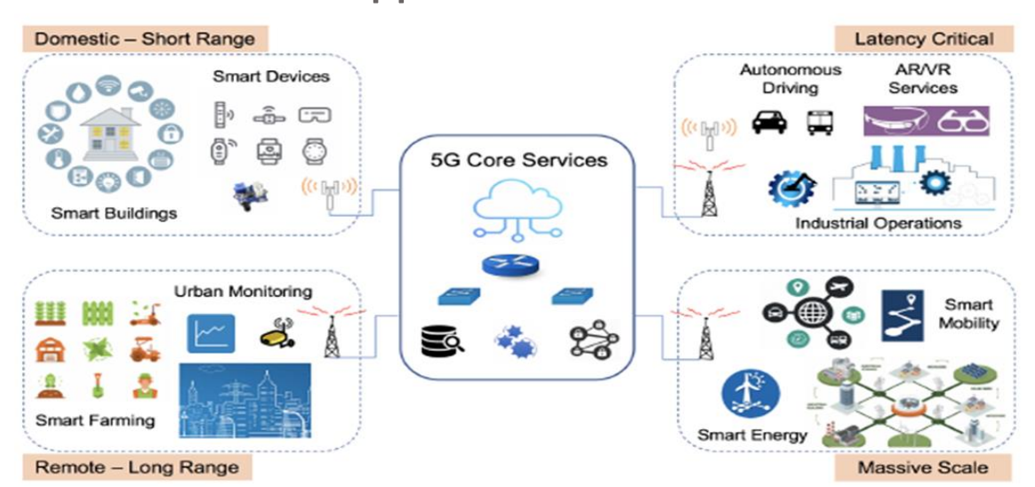

Q4.Explain following Architecture of 5G
a) Functional Architecture
b) Open wireless Architecture
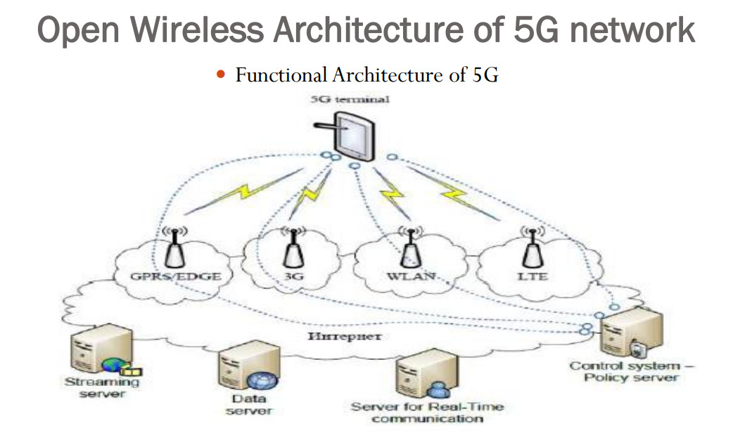
Open Wireless Architecture of 5G network
 The system comprising of a main user terminal and then a number of independent
and autonomous radio access technologies.
 Each of the radio technologies is considered as the IP link for the outside internet
world.
 The IP technology is designed exclusively to ensure sufficient control data for
appropriate routing of IP packets related to a certain application connections i.e.
sessions between client applications and servers somewhere on the Internet.
 Moreover, to make accessible routing of packets should be fixed in accordance with
the given policies of the use

Q5.Explain WLAN system Architecture
Wireless Local Area Network
A series of IEEE 802.11 standards have been proposed to improve the performance of WLANs, provide higher data rates and better coverage at very low cost as follows:
➢ IEEE 802.11a: Ratified in 1999; operating in the 5 GHz band with data rate up to 54 Mbps. IEEE 802.11a provides eight channels using OFDM, with 52 subcarriers spanning over a 20 MHz wide spectrum. Each subcarrier can be modulated with BPSK, QPSK, 16-QAM, or 64-QAM, depending on the wireless environment. 802.11a has less interference than other IEEE 802.11 standards.
➢ IEEE 802.11g: Ratified in 2003 representing a further higher data rate extension in the 2.4 GHz band with data rate up to 54 Mbps. The PHY layer can use either DSSS or OFDM
IEEE 802.11d: It represents an official amendment to the IEEE 802.11 specification that adds whereby geographical information is added to transmitted frames; includes parameters like country name, channel quantity and maximum transmission level. ¬ IEEE 802.11e: This amendment defines a set of Quality of Service enhancements by making several modifications to the Media Access Control (MAC) layer. Includes packet bursting for the best transmission quality for voice and video applications. ¬ IEEE 802.11h: This amendment adds spectrum and transmit power management extensions. ¬ IEEE 802.11i: This amendment specifies security mechanisms for wireless networks calledWired Equivalent Privacy (WEP)
IEEE 802.11n: This amendment incorporates Multiple-input Multiple Output (MIMO) technology to improve network throughput. MIMO enhances performance with the use of multiple antennas at both the transmitter and receiver for multiple transmitted data streams, which leads to a considerable increase in data throughput (up to 600 Mbps) without additional cost of bandwidth or transmission power, benefiting from antenna diversity and spatial multiplexing. ¬ IEEE 802.11r: This amendment enables to manage handover in a seamless manner by permitting continuous connectivity aboard wireless devices in motion, with fast and secure handovers from one access point to another. ¬ IEEE 802.11u: This amendment specification improved interworking with external networks.

Q6.Write short note on IEEE 802.11 DSSS
WIRELESS LOCAL AREA NETWORK (IEEE 802.11 )
➢ Used both for indoor and outdoor installations.
➢ They support two types of networks:Ad-hoc and infrastructure.
➢ In the infrastructure mode, the network consists of a wireless access point (AP) and
several wireless clients. The AP coordinates the transmission among stations within
its radio coverage area, called Basic Service Set (BSS). It is also responsible for
bridging the wireless traffic to the wired local area network as well as being
responsible for security management. BSSs are interconnected with each other via
a component called a Distribution System (DS).
➢ All wireless clients communicate with external networks through the AP. Such a
configuration is called an Extended Service Set (ESS).
Ad-hoc networks represent an evolution of infrastructure mode which remove
fixed infrastructure. In fact, they consist of self-organized networks, with only
wireless clients included which communicate directly with each other without
forwarding packets to an access point.
➢ This mode is suitable for rapidly setting up a wireless network in a conference
room, or anywhere else where enough wired equipment does not exist.\

Q7. Compare 1G, 2G,3G,4G and 5G

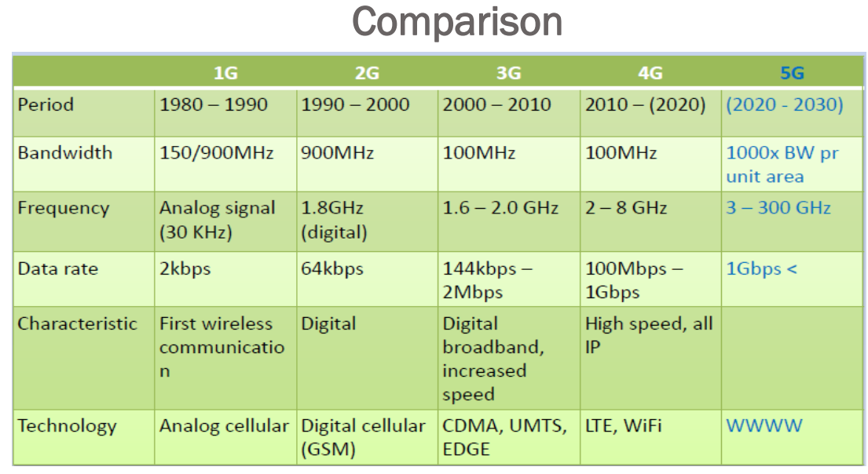

Q8. Compare LTE and LTE-A.
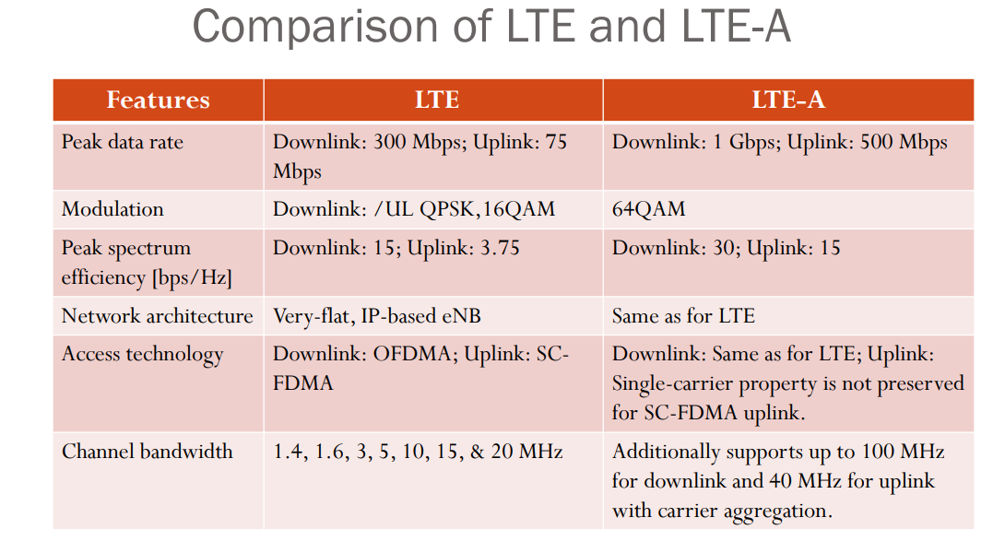
Q9. List out three, why there is a need of series of 802.11 standards. Describe the utility of IEEE80 2.11a and 80 2.11n.
Refer Q5 answer.

Q10. With neat diagram, explain in detail Evolved Packet Core architecture of LTE.
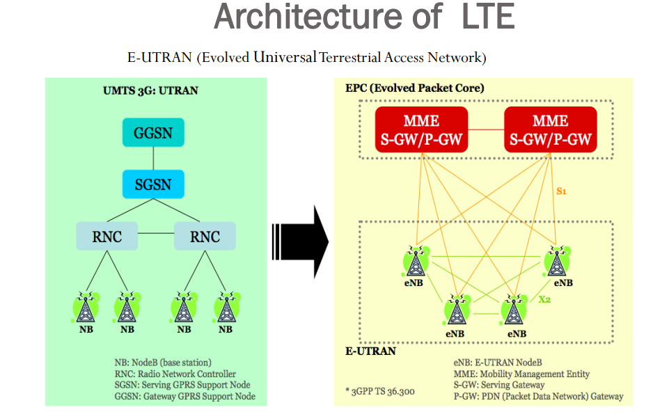

Architecture of LTE
 In the LTE architecture, evolved packet core (EPC) is an IP-based core network that distributes all types of information over IP, including voice.
 EPC principally includes a Mobility Management Entity (MME), a Serving Gateway (S-GW) that interfaces with the E-UTRAN, and a PDN Gateway (P-GW) that interfaces to external packet data networks.
 The entire system is known as the evolved packet system (EPS).
 EUTRAN handles the radio communications between the mobile and the EPC and has just one component, which is the evolved Node B (eNB).
 eNB in an LTE network replaces Node B in 3G systems and represents a combination of Node B and the radio network controller (RNC).
Every eNB is connected to the EPC by means of the S1 interface. Precisely, it is connected to the S-GW by means of the S1-U interface and to the MME by means of the S1-MME interface.
• The eNB interfaces with User Equipment (UE) and can serve one or several cells at one time.
• The serving gateway (S-GW) acts as a router that is responsible for routing and forwarding packets between UEs and the packet data network (PDN), so it interfaces with the E-UTRAN and a PDN Gateway.
• Moreover, the S-GW serves as a mobility anchor for handover and interworking with other 3GPP technologies. The packet data network gateway (PDN-GW) ensures connectivity to the UE to outer packet data networks, as it represents the EPC’s point of contact with the external world. A mobile could have simultaneous connectivity with several PDNGWs for accessing multiple packet data networks.
• The PDN-GW is responsible for several functions such as packet filtering, charging support, policy enforcement, packet screening, IP address allocation for the UE, QoS enforcement and lawful interception.
• The mobility management entity (MME), manages UE access network and mobility.
• The MME also controls mobility between LTE and 2G/3G access networks.

Q11. List our detail specification of LTE
 Packet-Domain-Services only (e.g. VoIP)→ upon LTE, TCP/IP- based layers
 Higher peak data rate/ user throughput → 100 Mbps DL/50 Mbps UL @20MHz bandwidth
 Reduced delay/latency → user-plane latency<5ms
 Improved spectrum efficiency → up to 200 active users in a cell @5MHz bandwidth
 Mobility → optimized for low-mobility (up to 15Km/h), supported with high performance for
medium mobility (up to 120 Km/h), supported for high mobility (up to 500 Km/h)
 Multimedia broadcast & multicast services
 Spectrum flexibility
 Multi-antennas configuration (MIMO)
 Coverage → up to 30 Km
 Multiplexing →FDD / TDD
 Modulation →QPSK, 16QAM, 64QAM

